***Error 404***

Introduction

The website is a search-based movie finder. It works on the basic principle of picking out keywords from the input provided by the user. For example, if you search “romantic movie starring Shah Rukh Khan that will make me happy”. It would pick out the keywords “romantic”, “Shah Rukh Khan” and “happy” and give you the movie coming under all these categories.

User Research

Generally when we want to watch a movie according to our mood or a specific genre or a specific actor etc, we are unable to find the perfect movie satisfying all that. This is where our website comes in. The website Error 404, would give you that movie in just one quick search.

Information Architecture

Home page

Mood

Search bar

Log in and sign in

Actors

Popularity

Genre

Search movies based on mood, actor, popularity, or/and genre

Happy

Top 10 - worldwide

Action

Movies of the actor searched

Top 10 – India

Gloomy

Adventure

Inspired

Comedy

Top latest releases

Crime

Angry

Drama

Bored

Romantic

Science fiction

Romance

Horror

Historical

Fantasy

Wireframes and Mockups

Homepage

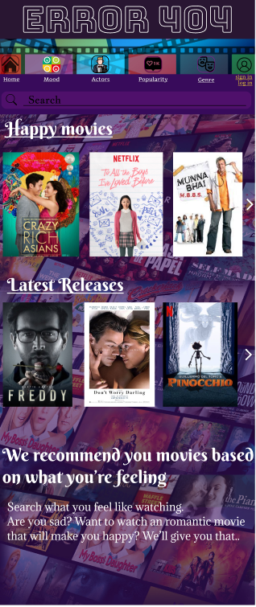

Search what kind of movie you feel like watching

Sample popularity based movies

Sample mood based movies option

Option to get movie of specific actors

Account information

Option to get movie based on genre

Option to get popular movies

Option to get movie based on mood

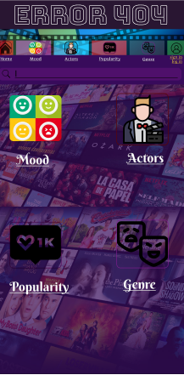

Genre based movies

Popular movies

Specific actor based movies

Mood based movies

Mood Based Movies

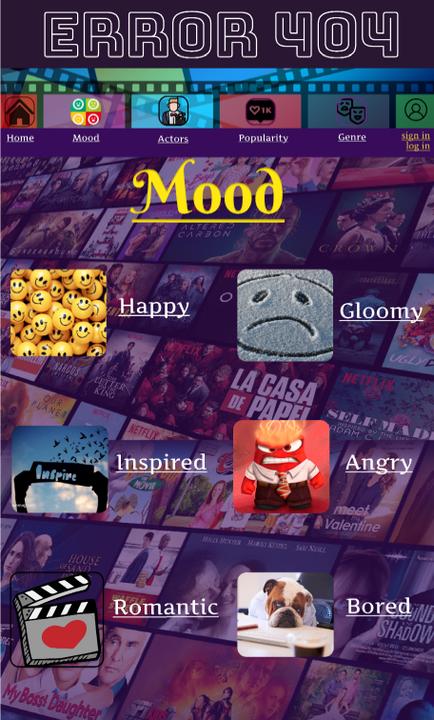

Option to watch movies when you are angry

Option to watch movies when you are bored

Option to get gloomy movie

Option to get romantic movie

Option to get inspiring movie

Option to get happy movie

Movies of specific actors

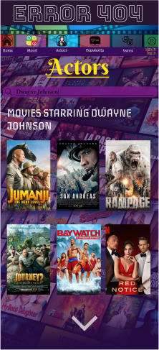

Movies based on popularity

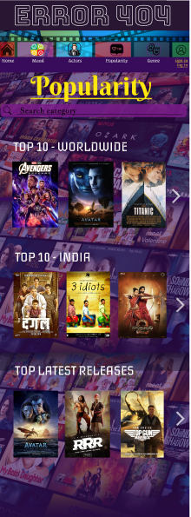

Genre based movies



Fantsy movies

Historical movies

Horror movies

Science Fiction related movies

Romantic movies

Drama movies

Crime movies

Comedy movies

Adventure movies

Action movies

Example of movies based on mood: Happy movies

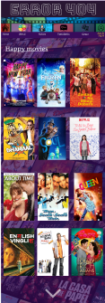

Example of specific search result

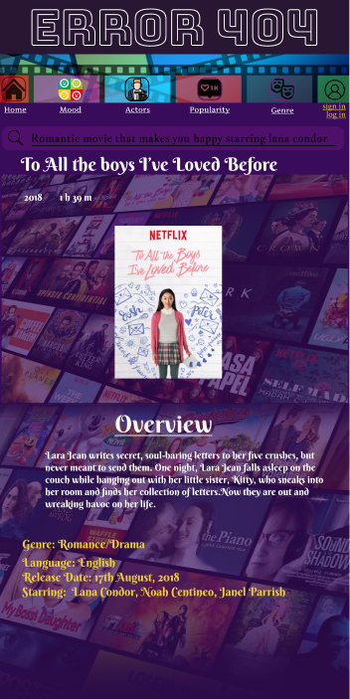

Discription of movie

Prototypes

<https://www.figma.com/proto/zdrHfSCaLZL1UBMhUasQLQ/Error-404?node-id=50%3A3&scaling=min-zoom&page-id=0%3A1&starting-point-node-id=50%3A3>

Edge cases

We were not able to create it more detailed, we selected a small database with only few movies for demonstration, just because of limited time . If we had more time then we would have been able to add more features to this website.

Future Scope

1) We can add more animations.

2) We can make it more interactive and user friendly.

3) We can make the design more efficient.